Evolution of Generative AI
Pre-2017: RNNs and LSTMs Era
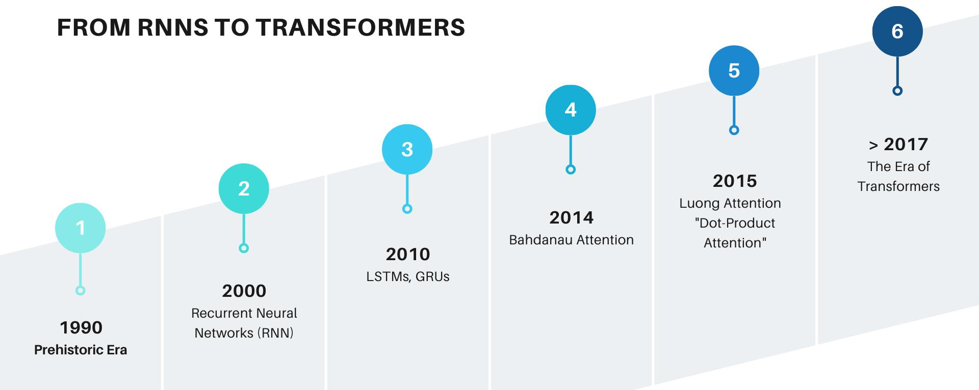
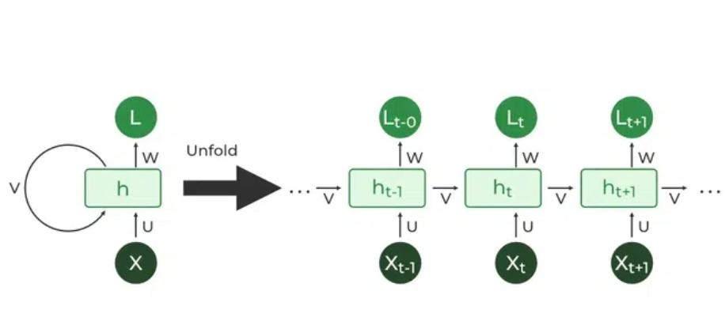
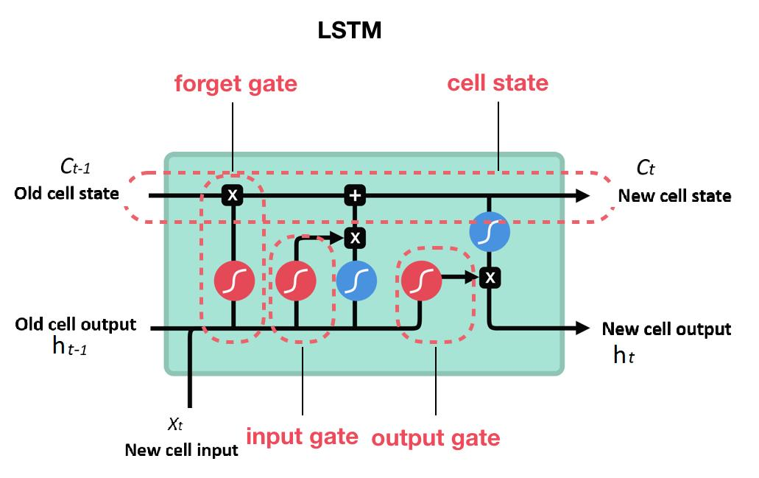
What was used
- Recurrent Neural Networks (RNNs)
- Long Short-Term Memory (LSTM)
How they worked
- Process data sequentially (one word at a time)
- Maintain memory of previous inputs
Limitations
- Slow (no parallel processing)
- Struggled with long sentences (vanishing gradient problem)
- Poor long-range context understanding
Example Problem
Sentence:
"The data pipeline failed because the schema changed yesterday"
RNN might forget “schema changed” when reaching end.

2017: Transformers Introduced (Revolution)
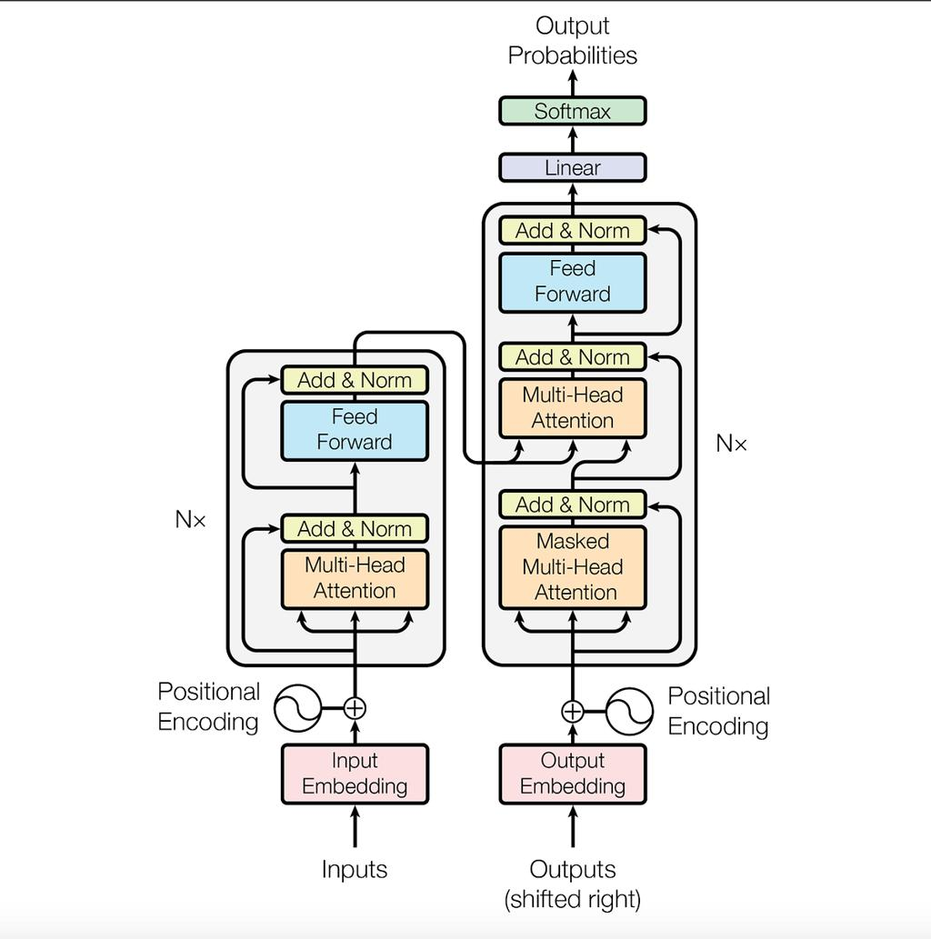
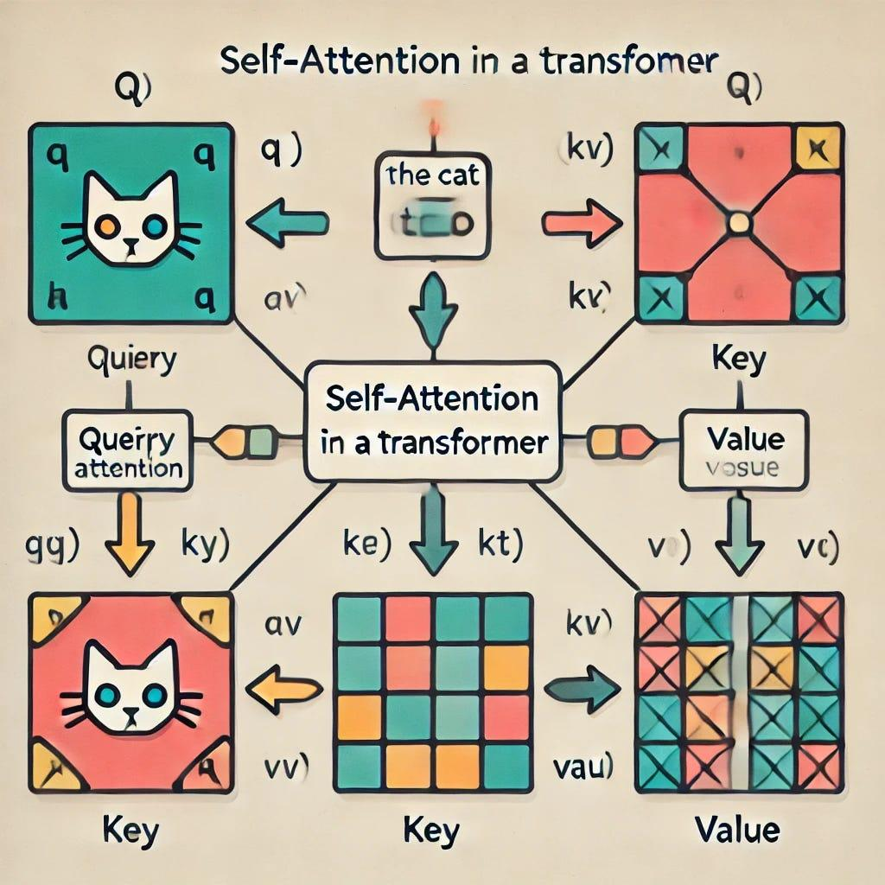
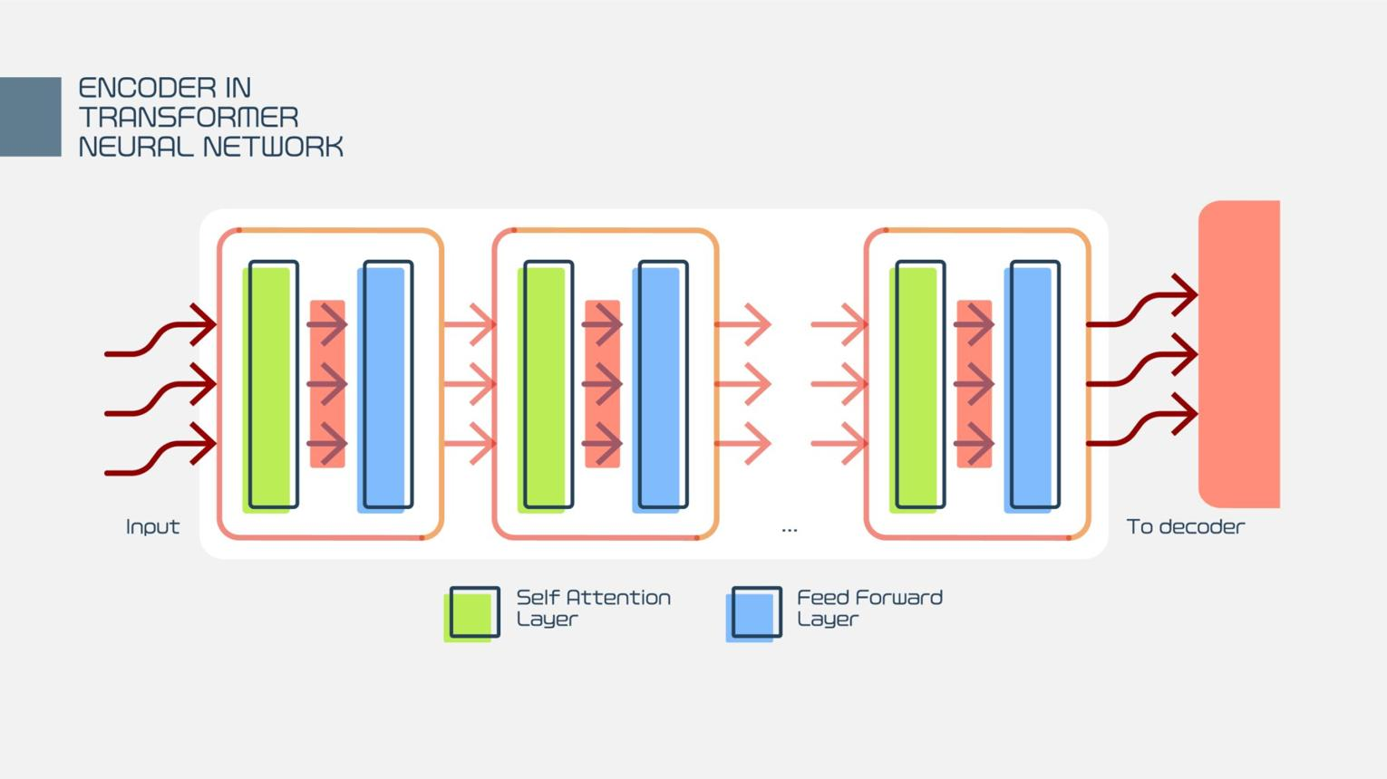
Breakthrough Paper
“Attention Is All You Need”
Key Innovation
- Self-attention
What changed
- Models can look at entire sentence at once
- No sequential limitation
- Massive parallel processing
Benefits
- Better context understanding
- Faster training
- Scales to large datasets
Why it matters
This is the foundation of all modern LLMs

2022+: Explosion of LLMs
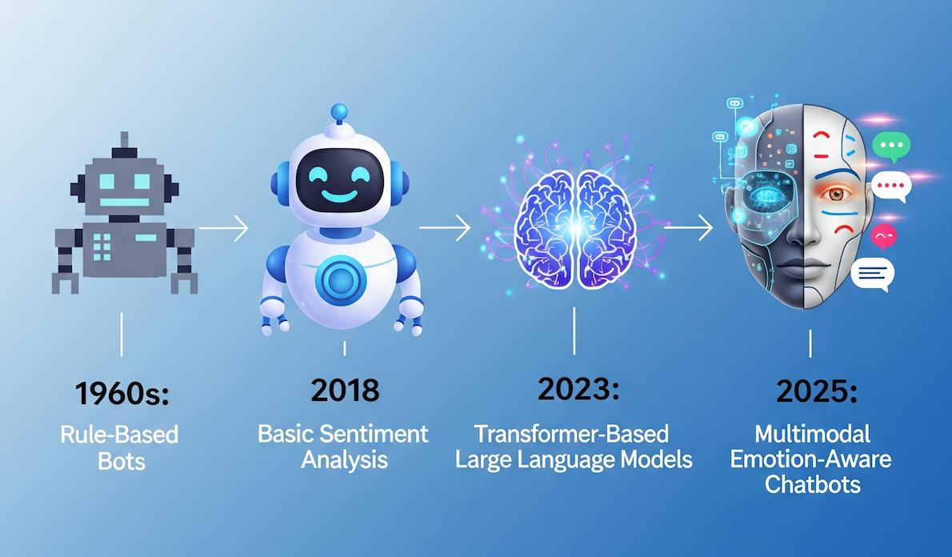
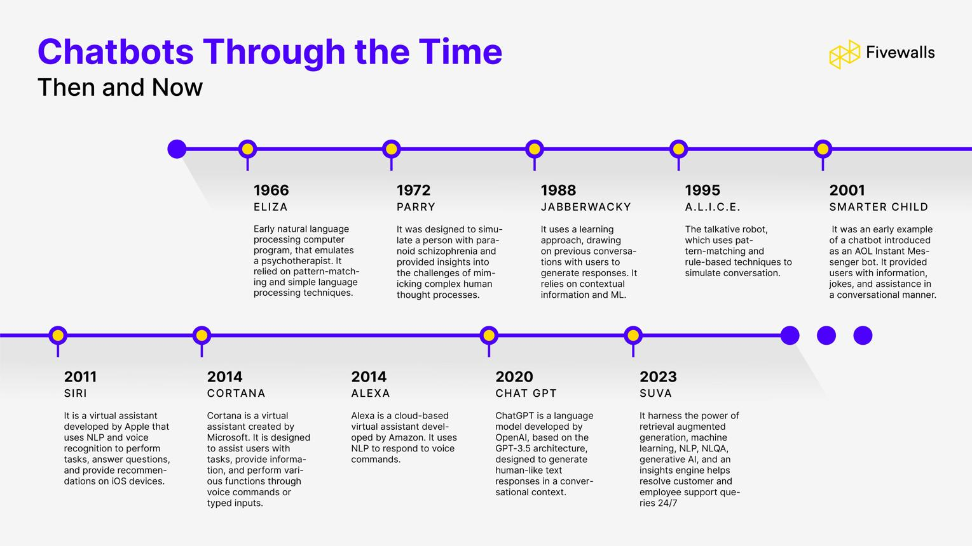
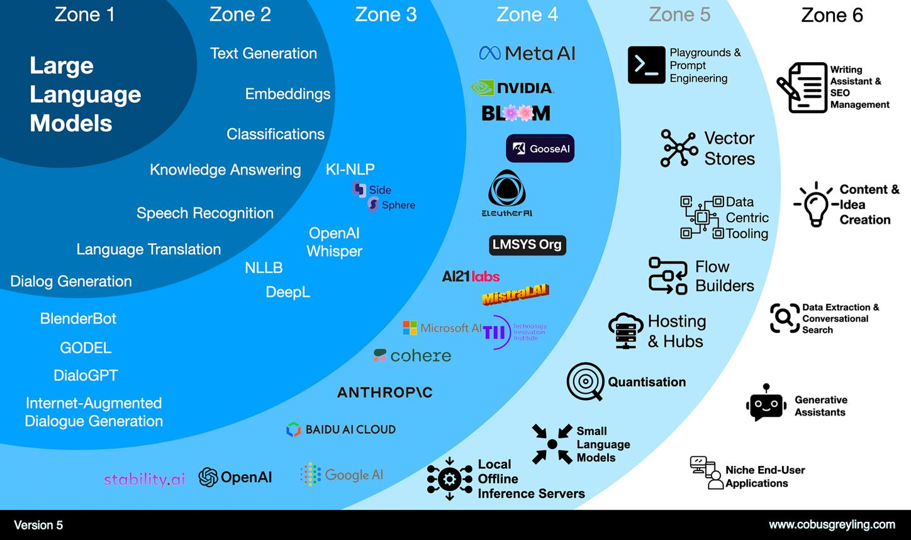
What happened
- Release of powerful models like:
  - ChatGPT
  - Claude
Key shift
- AI moved from research → mainstream usage
Capabilities
- Code generation
- Natural conversations
- Content creation
- Data analysis
Industry Impact
- Developers using AI daily
- Enterprises adopting AI
- New roles (Prompt Engineer, AI Engineer)

2024–2025: Multimodal & Agentic AI
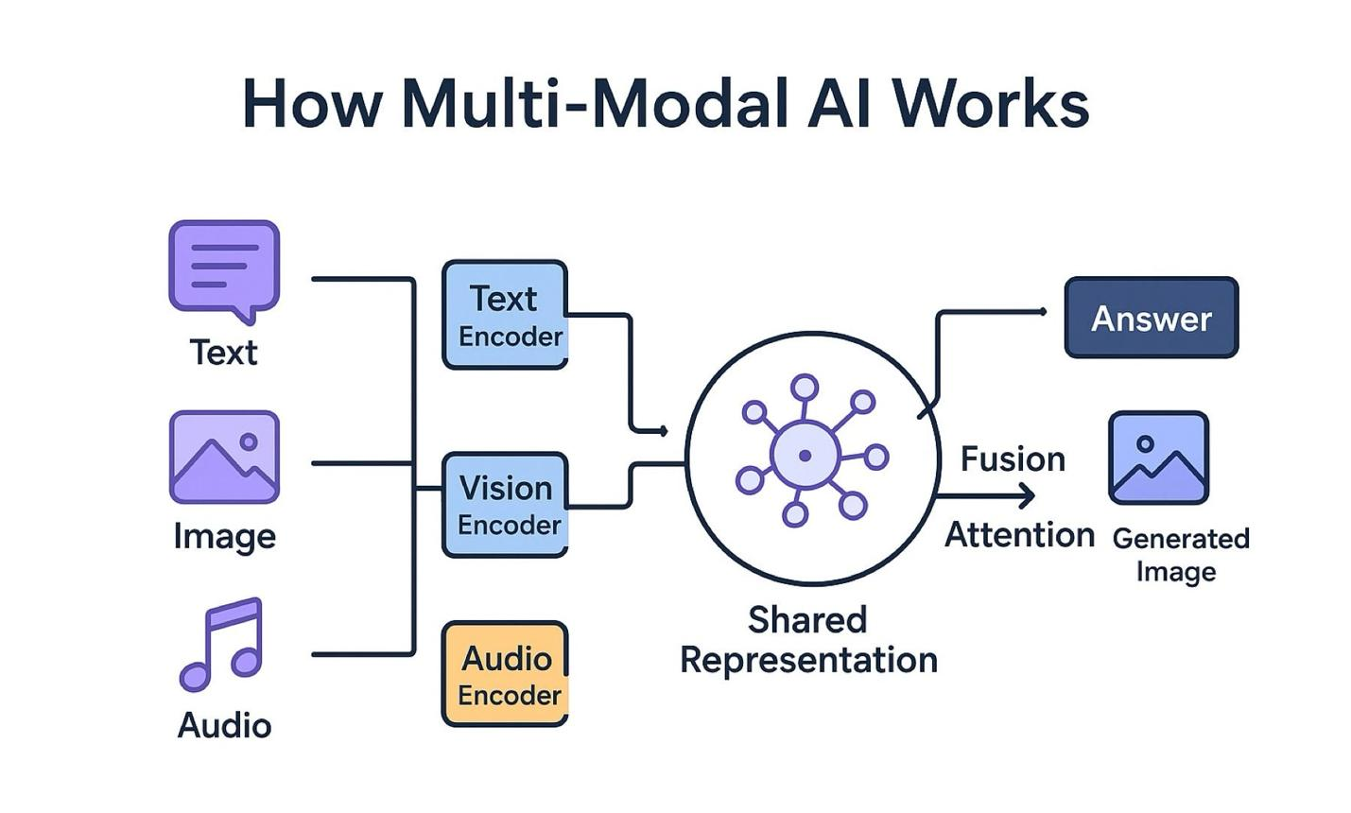
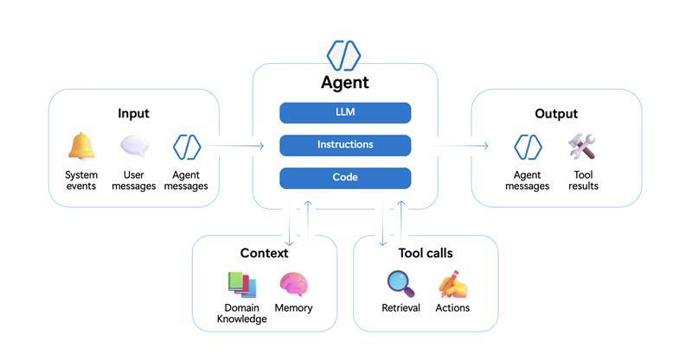
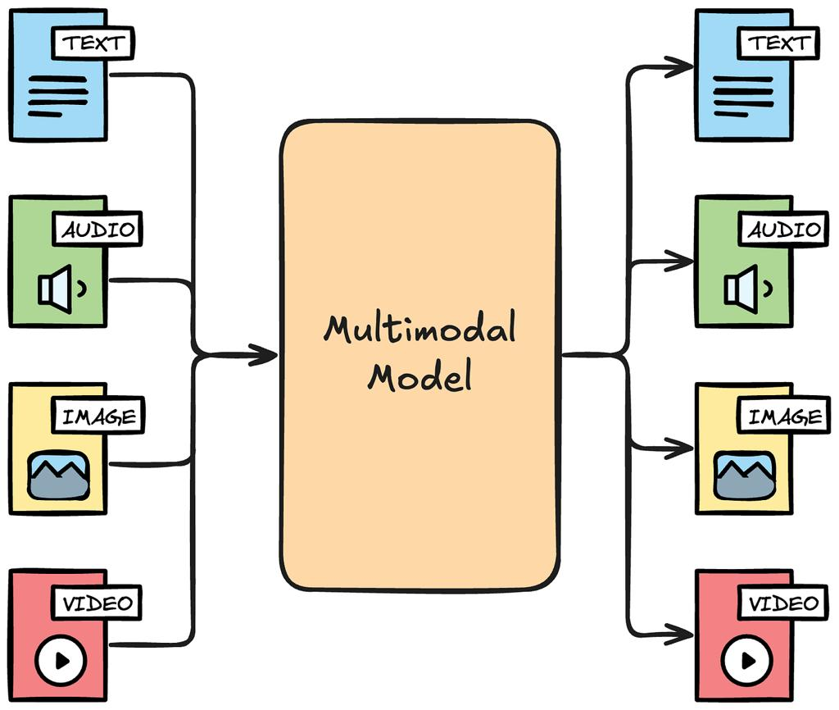
Multimodal AI
Models can handle:
- Text
- Images
- Audio
- Video
Examples:
- GPT-4o
- Gemini

Agentic AI (Big Shift)
AI systems that can:
- Plan tasks
- Call APIs
- Execute workflows
- Iterate autonomously
Example
Instead of:
“Write SQL query”
AI can:
- Understand requirement
- Generate SQL
- Run it
- Fix errors
- Return result

Why this phase is important
- AI is moving from assistant → autonomous system
- Heavy adoption in:
  - Data Engineering
  - DevOps
  - Business automation

Final Summary
- RNN/LSTM → sequential, limited memory
- Transformers → parallel, attention-based (breakthrough)
- 2022 → LLMs became mainstream
- 2024–25 → AI became multimodal and agent-driven

